Supplemental Material
Electronic control unit (ECU)
The ECU combines a trigger unit and a rechargeable battery to control and power the pellet dispenser, making the ZACI completely independent from any external power supply while being used.
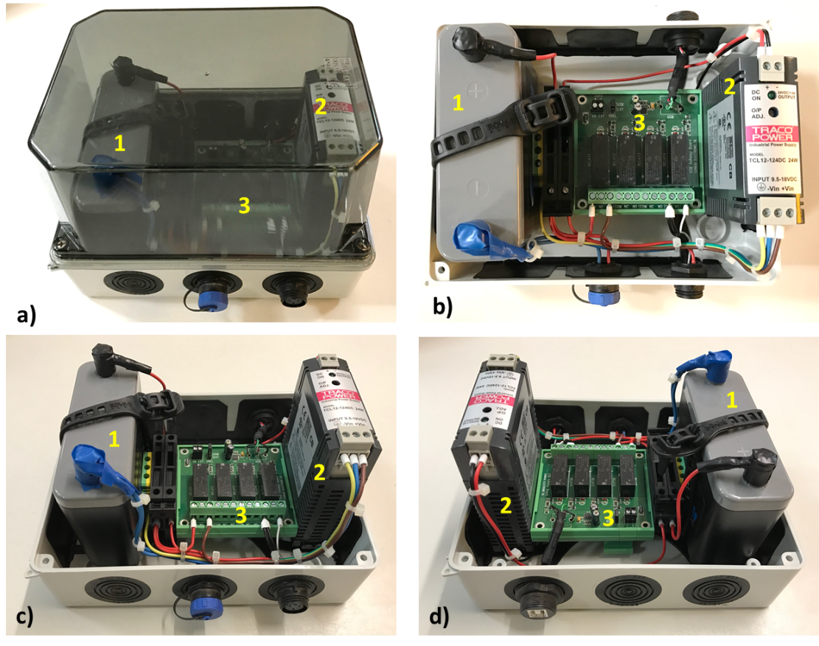
Figure S1: Pictures of the self-developed electronic control unit (ECU) including a motorcycle battery (1), a DC/DC converter (2), and USB relay card (3) secured in an installation box using top hat rail mounting.
The main components included in the ECU are a motorcycle battery (Lithium Powerbloc 2,5 Ah 13.2 V 2500 mAh, bought at www.moto-technik.com, a DC/DC converter (TracoPower TCL 012-124DC 28 V/DC 1 A 12 W, bought at www.conrad.de , and a USB relay board (USB 4-channel Relay Card Module 5 V / DC Output power 8 A / 24 V / DC, bought at https://www.conrad.de) (see Figure S1). The pellet dispenser is powered by the motorcycle battery via the DC/DC converter. The DC/DC converter is necessary as the battery delivers 12V but the pellet dispenser needs 28V to function. The USB relay card creates the trigger impulse for the pellet dispenser, and is powered via USB from the laptop. In order to save power when no trigger is performed (the pellet dispenser needs also power when idling) the power of the DC/DC (and thus the pellet dispenser) is also controlled via the USB relay card (see description of ECU software).
All components of the ECU are secured in a moisture-proof (IP65) installation box using top hat rail mounting (JS7291 installation box with transparent lid and membrane guides 150 x 110 x 135 mm, by Spitzenspannung Elektrotechnik, bought at https://www.amazon.de ). In addition to the main parts (i.e. battery, DC/DC converter, relay card), the ECU includes two fuses, a grounding terminal, cable and mounting connectors (Buccaneer® by Bulgin, UK, bought at https://www.conrad.de ), and the connecting wires. The assembling scheme depicted in Figure S2 shows the detailed connections of the components. To maintain the moisture-proof settings of the installation box, the USB relay card was modified by removing the USB socket from the board (marked red) and installing a USB connector instead (ASSMANN WSW A-USB-BPFS USB Connector 2.0 - IP67 Socket, build-in USB B-socket on 5 pin connector by ASSMANN Electronic GmbH, Lüdenscheid, Germany, bought at https://www.conrad.de) linking the relay card with the installation box and moving the USB socket to the outside (see Figure S1d). Furthermore, we modified the connection of the pellet dispenser by removing the attached plug and replacing it with a 3 pin cable connector (Bulgin PX0410/03P/5560 400 Series Buccaneer Connector, bought at http://www.conrad.de), which can be attached to the installation box. 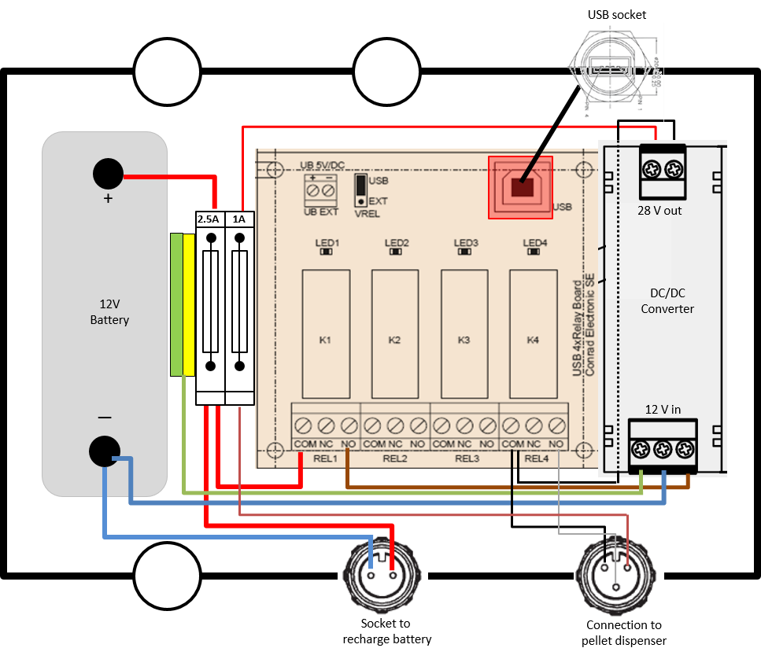
Figure S2: Assembling scheme of the ECU. The thickness of the connecting wires indicates the current, i.e. the thicker the lines the more current they transmit.

ECU Software
The manufacturer of the USB relay board provides a shared library (CP210xRuntime.dll, https://www.conrad.de), which is needed to control the relays. In addition, a console executable was developed using Microsoft® Visual Studio 2013 and C/C++, to load the provided library and to activate the relays as requested via command line arguments included in the main behavioural software program. This main software program has hooks to incorporate the food dispenser / software controlling the USB relay card.
The developed executable can also be integrated into other software programs and is available for download (Folder: “ElectronicControlUnit.exe” including also the CP210xRuntime.dll). For clarification, this ECU program expects an integer argument, which represents the active and inactive relays in binary representation. As the relay board consists of four relays it needs to be specified, which relay should be turned on and off. For example, in the proposed setup, to turn on the power DC/DC (power on the pellet dispenser) the first relay must be activated (binary 0001 decimal 1). This can be achieved by executing “ElectronicControlUnit.exe 1” in the main software program. To dispense food the 4th relay must be activated in addition for a few milliseconds while relay 1 stays on (binary 1001 => decimal 9): “ElectronicControlUnit.exe 9”.
For some behavioural programs, like EPrime®, it is easier to incorporate a shared library. Therefore, a shared library, which can be used in EPrime®, as well as a sample EPrime® script incorporating the DLL, is also available for download (Folder: “for_EPrime” includes the sample EPrime file, the 32-bit version of the ElectronicControlUnitDLL.dll + 32-bit version of CP210xRuntime.dll, which needs to be placed into EPrime’s program folder, e.g. "C:\Program Files (x86)\PST\E-Prime 3.0\Program").
In the User Script section the following code is needed:
Declare Function writeECU Lib "ElectronicControlUnitDLL.dll" Alias "_writeECU@4" (ByVal value As Integer) As Integer
Dim retValue As Integer

Function dispenseFood ()
' relay mapping:
' relay n => 2^(n-1)
' relay 1 => 2^0 = 1
' relay 2 => 2^1 = 2
' relay 3 => 2^2 = 4
' relay 4 => 2^3 = 8
retValue = writeECU(1)
Sleep(1000)
retValue = writeECU(1+8)
Sleep(100)
retValue = writeECU(1)
Sleep(3000)
retValue = writeECU(0)
End Function
The dispenseFood function is invoked via InLine script:
Dim ret
ret = dispenseFood()
In case other software programs are used, which require a shared library, the 32-bit version of the dll (Folder:“ElectronicControlUnitDll.dll 32 bit”) and the 64-bit Dll version (Folder ”ElectronicControlUnitDll.dll 64 bit”), are also available for download.

Assembly of the ZACI
The following pictures show the assembly of the Zoo-based Animal-Computer-Interaction system in more detail.
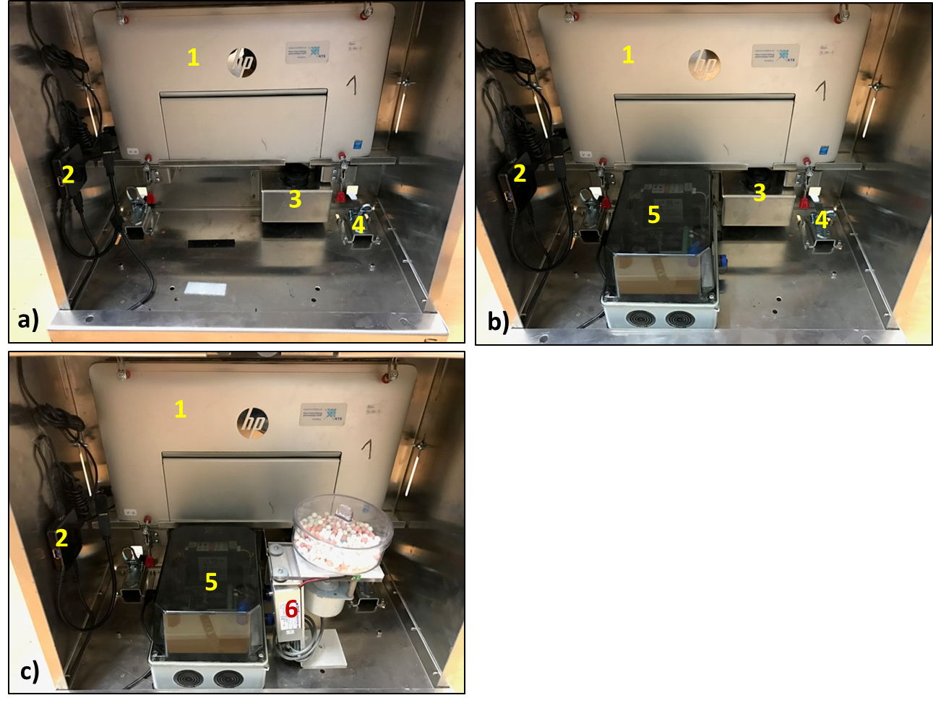
Figure S3: a) The inside of the ZACI with only the laptop (1) slide into the setup, showing the USB Hub (2), the outlet for reward pellets (3), and the lower fastening hooks (4). b) The ECU is attached to the metal casing via hook-and-loop tape (5). c) The pellet dispenser is fixed to the metal casing using a screw at the bottom and connected to the ECU (6).

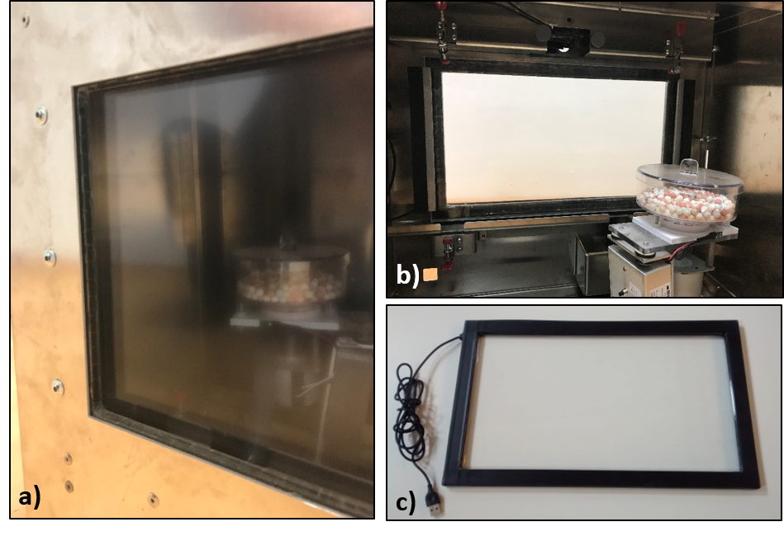
Figure S4: a) Detailed view of the IR-touchframe including the Plexiglas® panel from the front and b) the back of the ZACI, c) and the IR-frame as delivered by the company

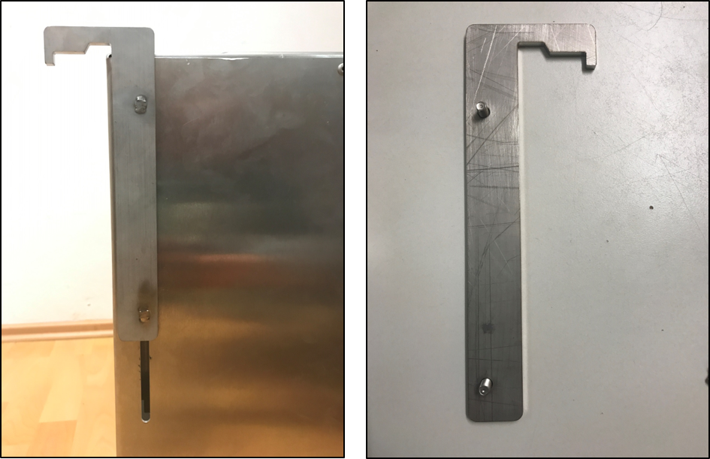
Figure S5: Detailed view of the upper hooks used to attach the system to the bars of the animals enclosure. These hooks can be slid up and down depending on the height of the bars. They can also easily be replaced by other hooks (e.g. of different shape).

